# Topic 2 Implement safeguard CIS 2.5 Allowlist Authorised Software

Your boss uses the Win11 virtual machine. Download the Win11 virtual machine from the uni website and import it into Virtualbox.

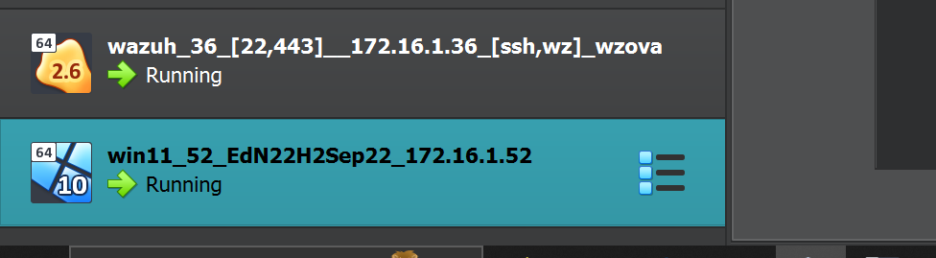

Setup a shared folder on Win11 for your scripts.

